Task 01:
What are the Advantages of Multi tier Architecture?
Advantages of Multi-tier Architecture
- Scalability: Each tier can be scaled independently to handle more users or load.
- Maintainability: Easier to update or modify one tier without affecting others.
- Reusability: Components of a tier can be reused across multiple applications.
- Flexibility: Supports different technologies in different tiers.
- Improved Security: Sensitive data can be handled in a separate, secure tier.
- Better Performance: Workload can be distributed across tiers for efficiency.
Hometasks::

Task01 ::

STrategy pattern,
Output::
Payment failed with Paypal
Payed with Credit Card , Amount ::: 100.0

Task02::
Command Pattern - Java code

Output::
Light is ON
Light is OFF

Task03::
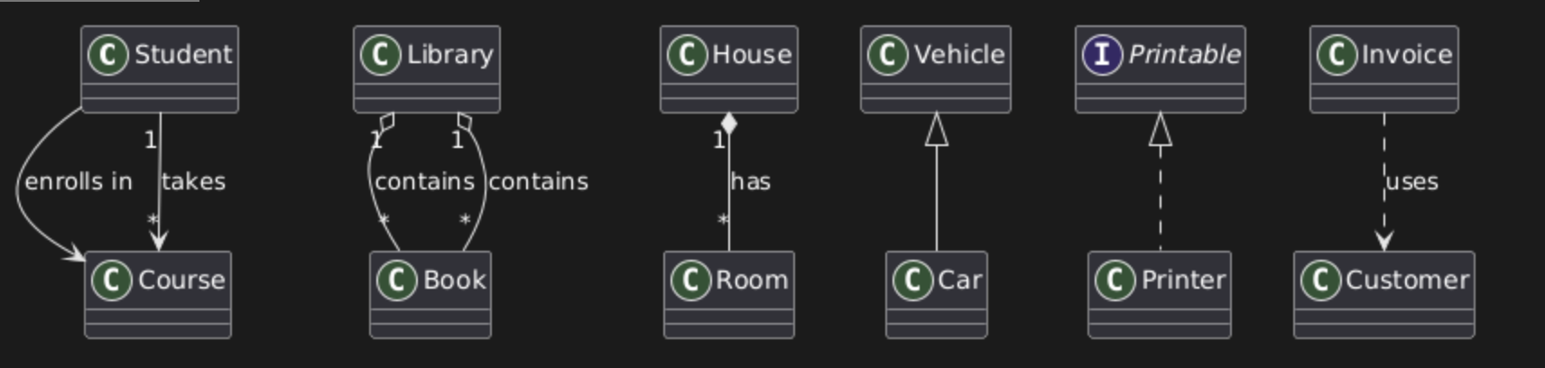
Task04:

